User Guide — TÀI Studio (Gen UI Rendering)
TÀI produces four types of surfaces in every turn: inline chat rendering, generative UI component surfaces, side-panel artifacts, and tool-driven surfaces. This guide covers all of them, plus the rules that decide which one is used.
──────────────────────────────────────────────────

1. Workspace Layout
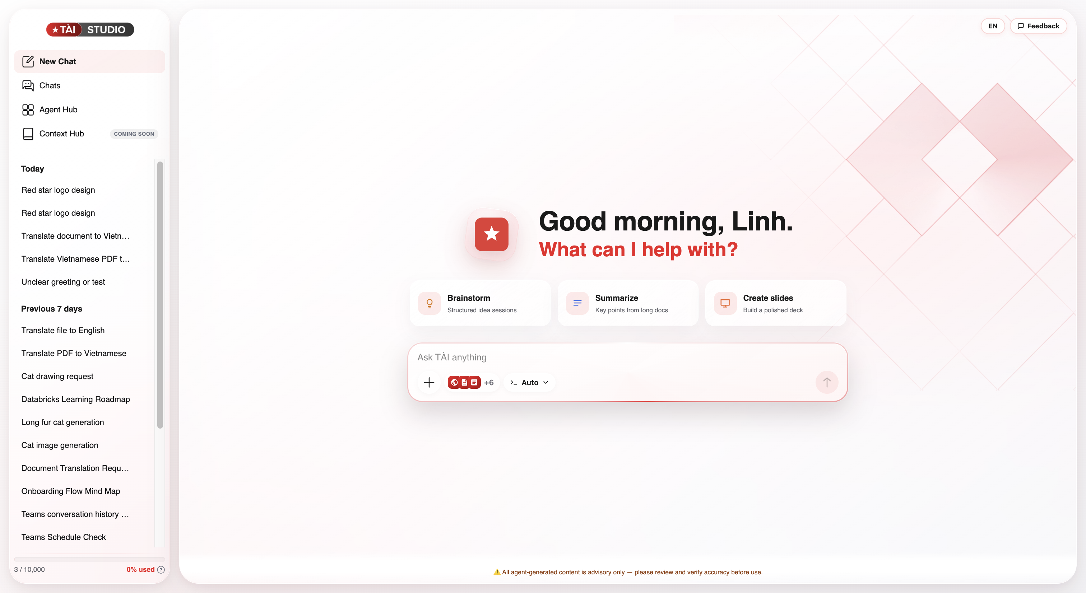
Area | What it does
Left sidebar | New Chat, conversation history (Pinned + Recent), Agents Hub, Context Hub (COMING SOON), token meter
Centre | The chat — where you type and see responses
Right panel | Opens on demand for artifacts, file preview, image preview, or specialist editors
When you first open a new chat, you'll see a personalised greeting and quick-start cards (e.g., Brainstorm, Summarize, Create slides). Click any card to get started.
──────────────────────────────────────────────────

2. Composer & Controls

Mode selector
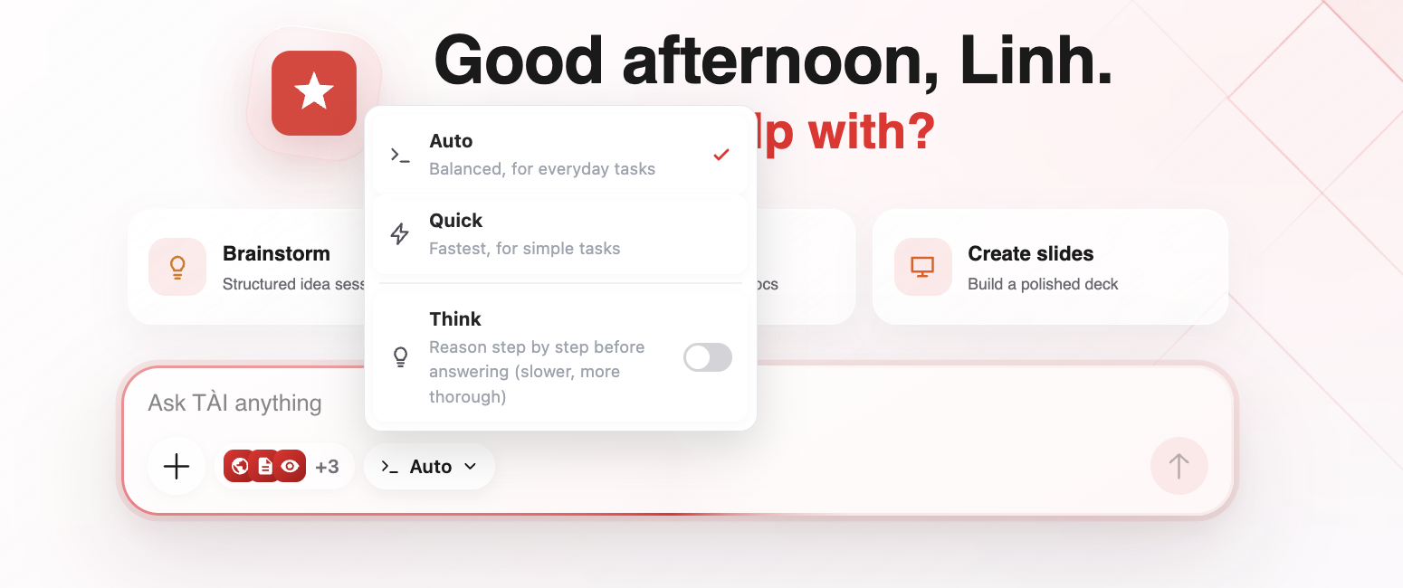
Click the mode pill in the composer to choose:
Mode | Best for
Auto (default) | Everyday tasks
Quick | Simple, fast answers
Deep research | Thorough answers using web sources (uses more credits)
Think (toggle) | Step-by-step reasoning — combines with any mode

@ Mention — routing to specialists
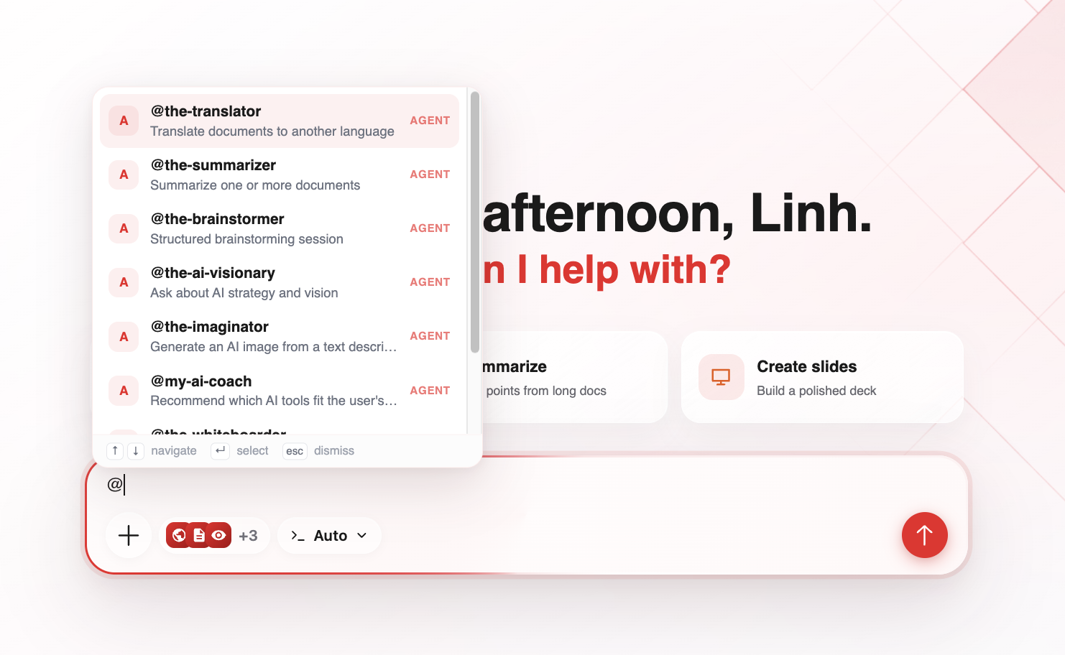
Type @ to open the autocomplete list. Each row shows the handle, description, and type badge (AGENT, MCP, KNOWLEDGE, GENIE). Examples:
- @the-imaginator: a red star logo on white background
- @the-translator: + attach a document
- @the-whiteboarder: loan approval flowchart

Connect Apps
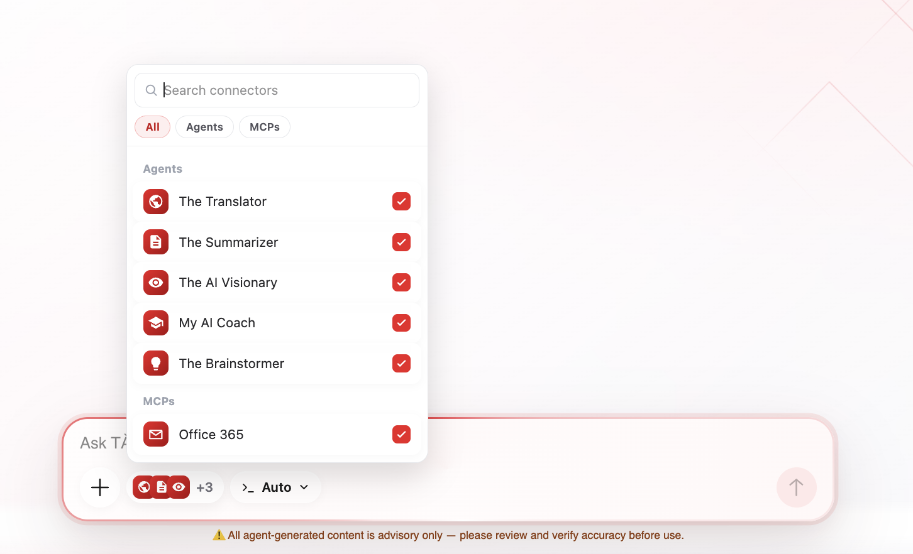
Click the connector pill to enable/disable external tools (Web Search, Office 365, Confluence, Knowledge Bases, Genie spaces, etc.). Only enabled tools are available for TÀI to use in the current turn.
──────────────────────────────────────────────────

3. Inline Chat Rendering
The default surface. TÀI writes the answer directly in the message; the chat renders full GitHub-flavored markdown. When in doubt, the answer stays inline.

Formatted text
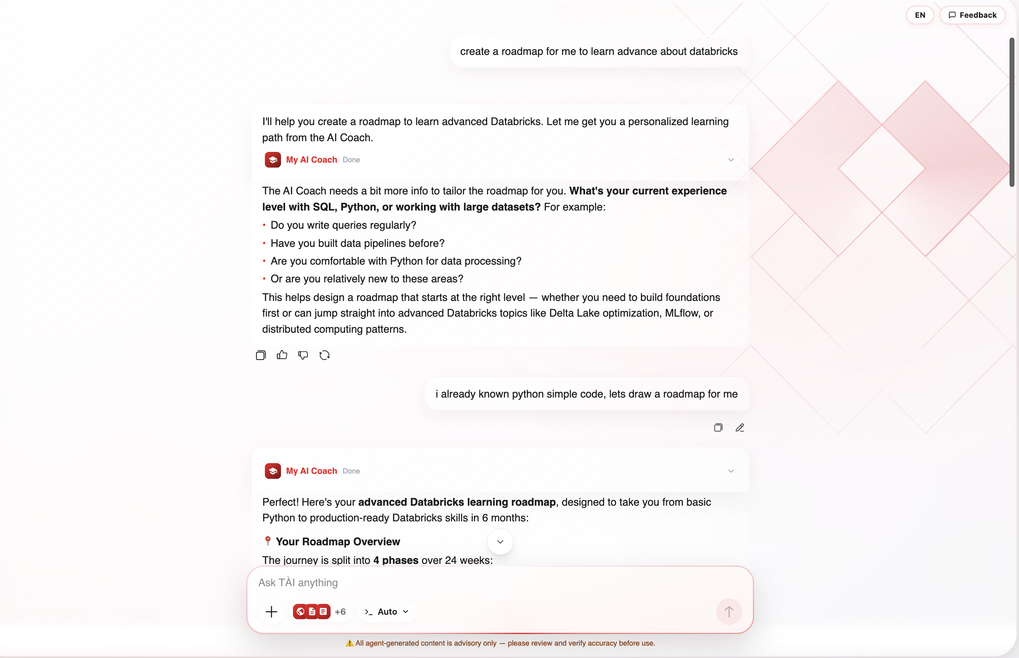
Headings, lists, bold/italic, links, blockquotes — for prose, explanations, analysis, writing.

Code block
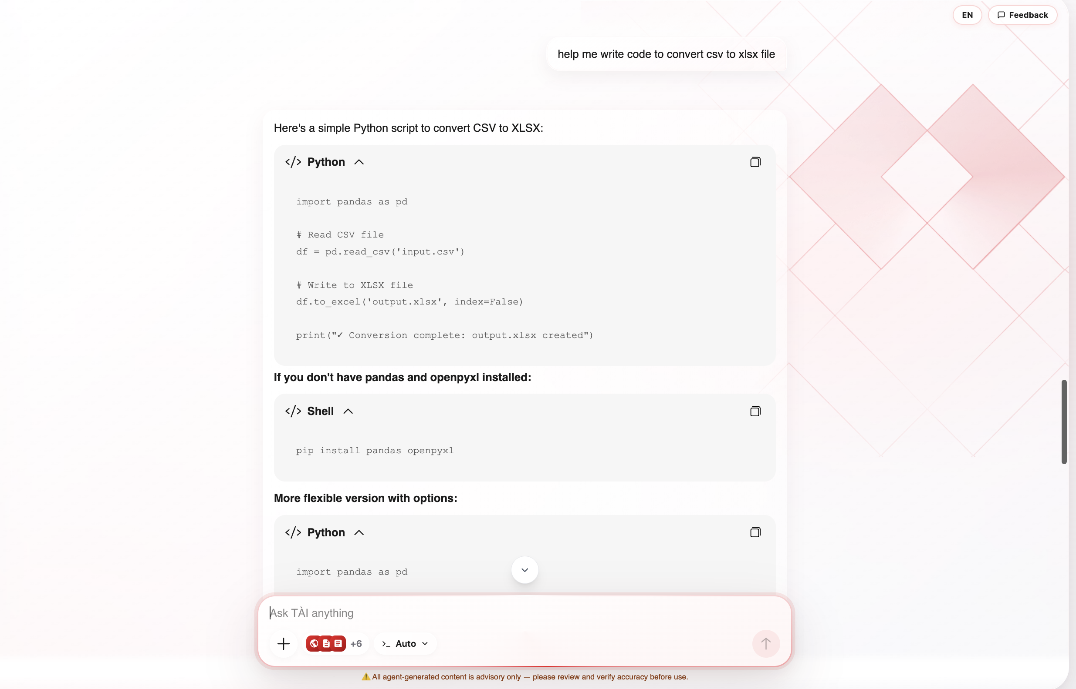
Fenced, syntax-highlighted code with a Copy button. Collapsible in the UI. Format: ```language … ```

GFM table
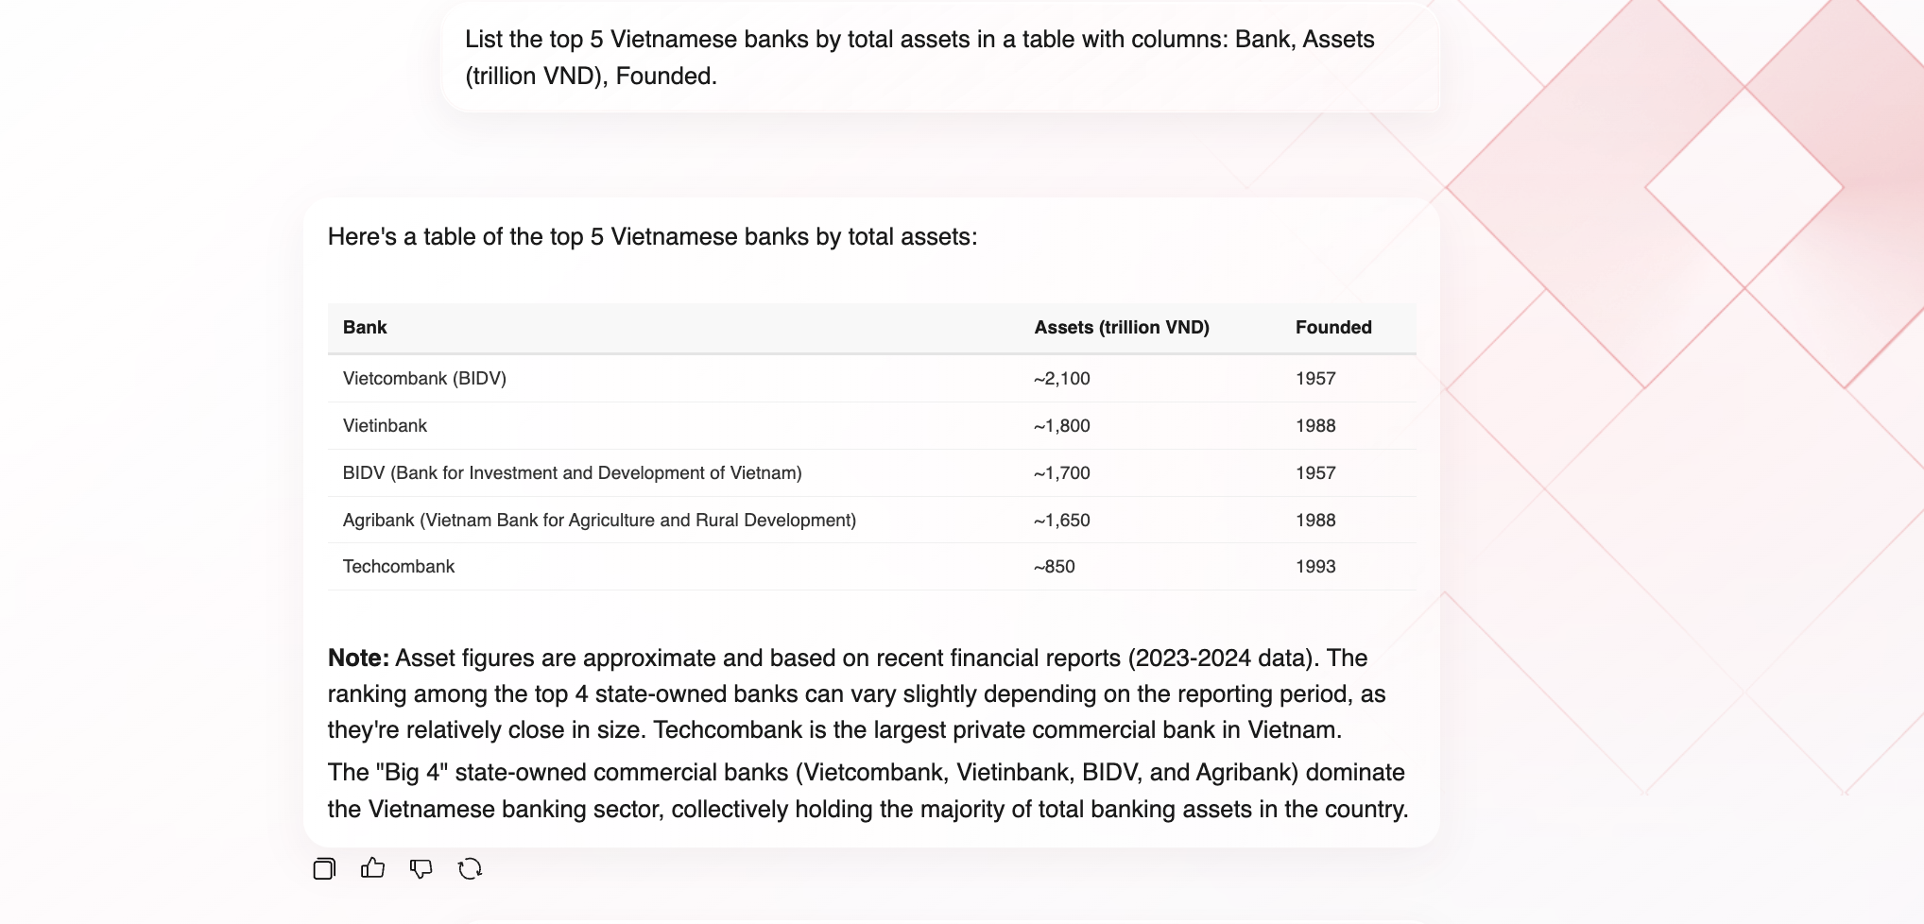
Markdown table for small, static structured data. Data returned from a query tool (Genie / SQL) must use a DataTable generative UI surface instead.

Mermaid diagram
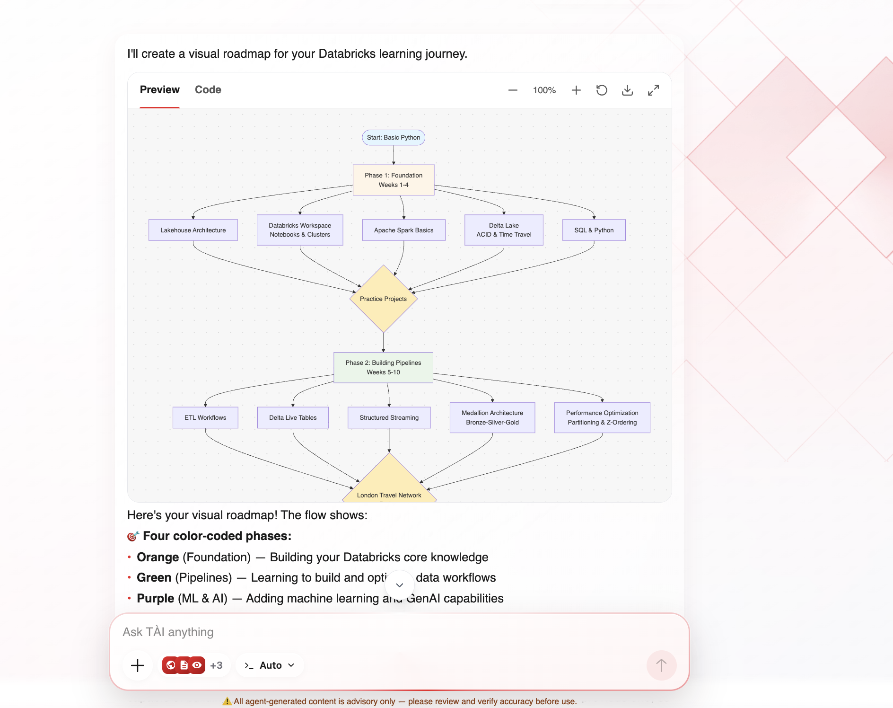
Diagrams rendered inline with Preview / Code tabs and controls: zoom in/out, fit, download, expand, copy source. Format: ```mermaid … ```

LaTeX math
Inline $…$ and block $$…$$ math expressions — for formulas only, written as LaTeX (no pre-rendered unicode alongside).

Citations
A trailing ## Sources section is parsed out, [n] markers become clickable links, and a sources panel is rendered. Triggered in Deep research mode.
──────────────────────────────────────────────────

4. Generative UI Surfaces (render_a2ui)
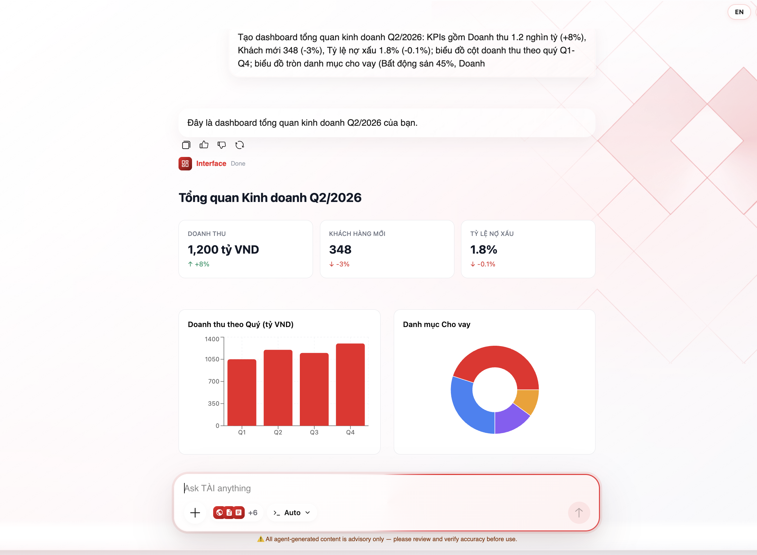
A real, interactive surface composed from a fixed catalog of components. The model never writes HTML — it picks components and fills their props. Charts are interactive (Recharts) at runtime.
Used when: quantitative data is genuinely clearer as a visual, the user asks for a dashboard/chart, or query tool results need to be displayed.

Layout components
Component | Description | Props
Card | Bordered white box around one child | title?, subtitle?, child
Row | Children side-by-side (wraps) | children[], gap?, align?, justify?
Column | Children stacked vertically | children[], gap?, align?, justify?
Section | Titled group of children | title?, children[], gap?

Inline elements
Component | Description | Props
Heading | Level 1–3 heading | text, level?
Text | Paragraph / label | text, muted?
Badge | Status tag in five tones (red, green, blue, amber, gray) | text, color?
Divider | Horizontal rule | —
Spacer | Vertical whitespace | size?

Interactive
Component | Description | Props
Button | Clicking dispatches an action back to the agent | label, variant? (primary|secondary|ghost), action{event{name, context?}}

Data & charts
Component | Description | Props
MetricGrid | Responsive KPI grid | metrics[]{label, value, trend?, delta?}
BarChart | Bars for comparing categories | title?, data[]{label, value}, orientation?
PieChart | Pie/donut for proportions | title?, data[]{label, value}
LineChart | Lines for trends over a series | title?, data[], xKey, series[]{key, label?, color?}
DataTable | Structured rows — REQUIRED for query-tool results | title?, columns[]{key, label}, rows[]
ComparisonTable | Compare items across criteria | title?, items[], criteria[]{label, values[]}
Timeline | Vertical event timeline | title?, events[]{date, label, description?}
FlowDiagram | Horizontal step flow | title?, steps[]{label, description?}

Dashboard layout rules
- Root is always a Column
- All KPIs go in ONE MetricGrid (not individual cards)
- Related charts sit side-by-side in a Row
- Surfaces fill the full width
- Every surface is followed by exactly one short caption sentence
──────────────────────────────────────────────────

5. Side-Panel Artifacts (openArtifact)
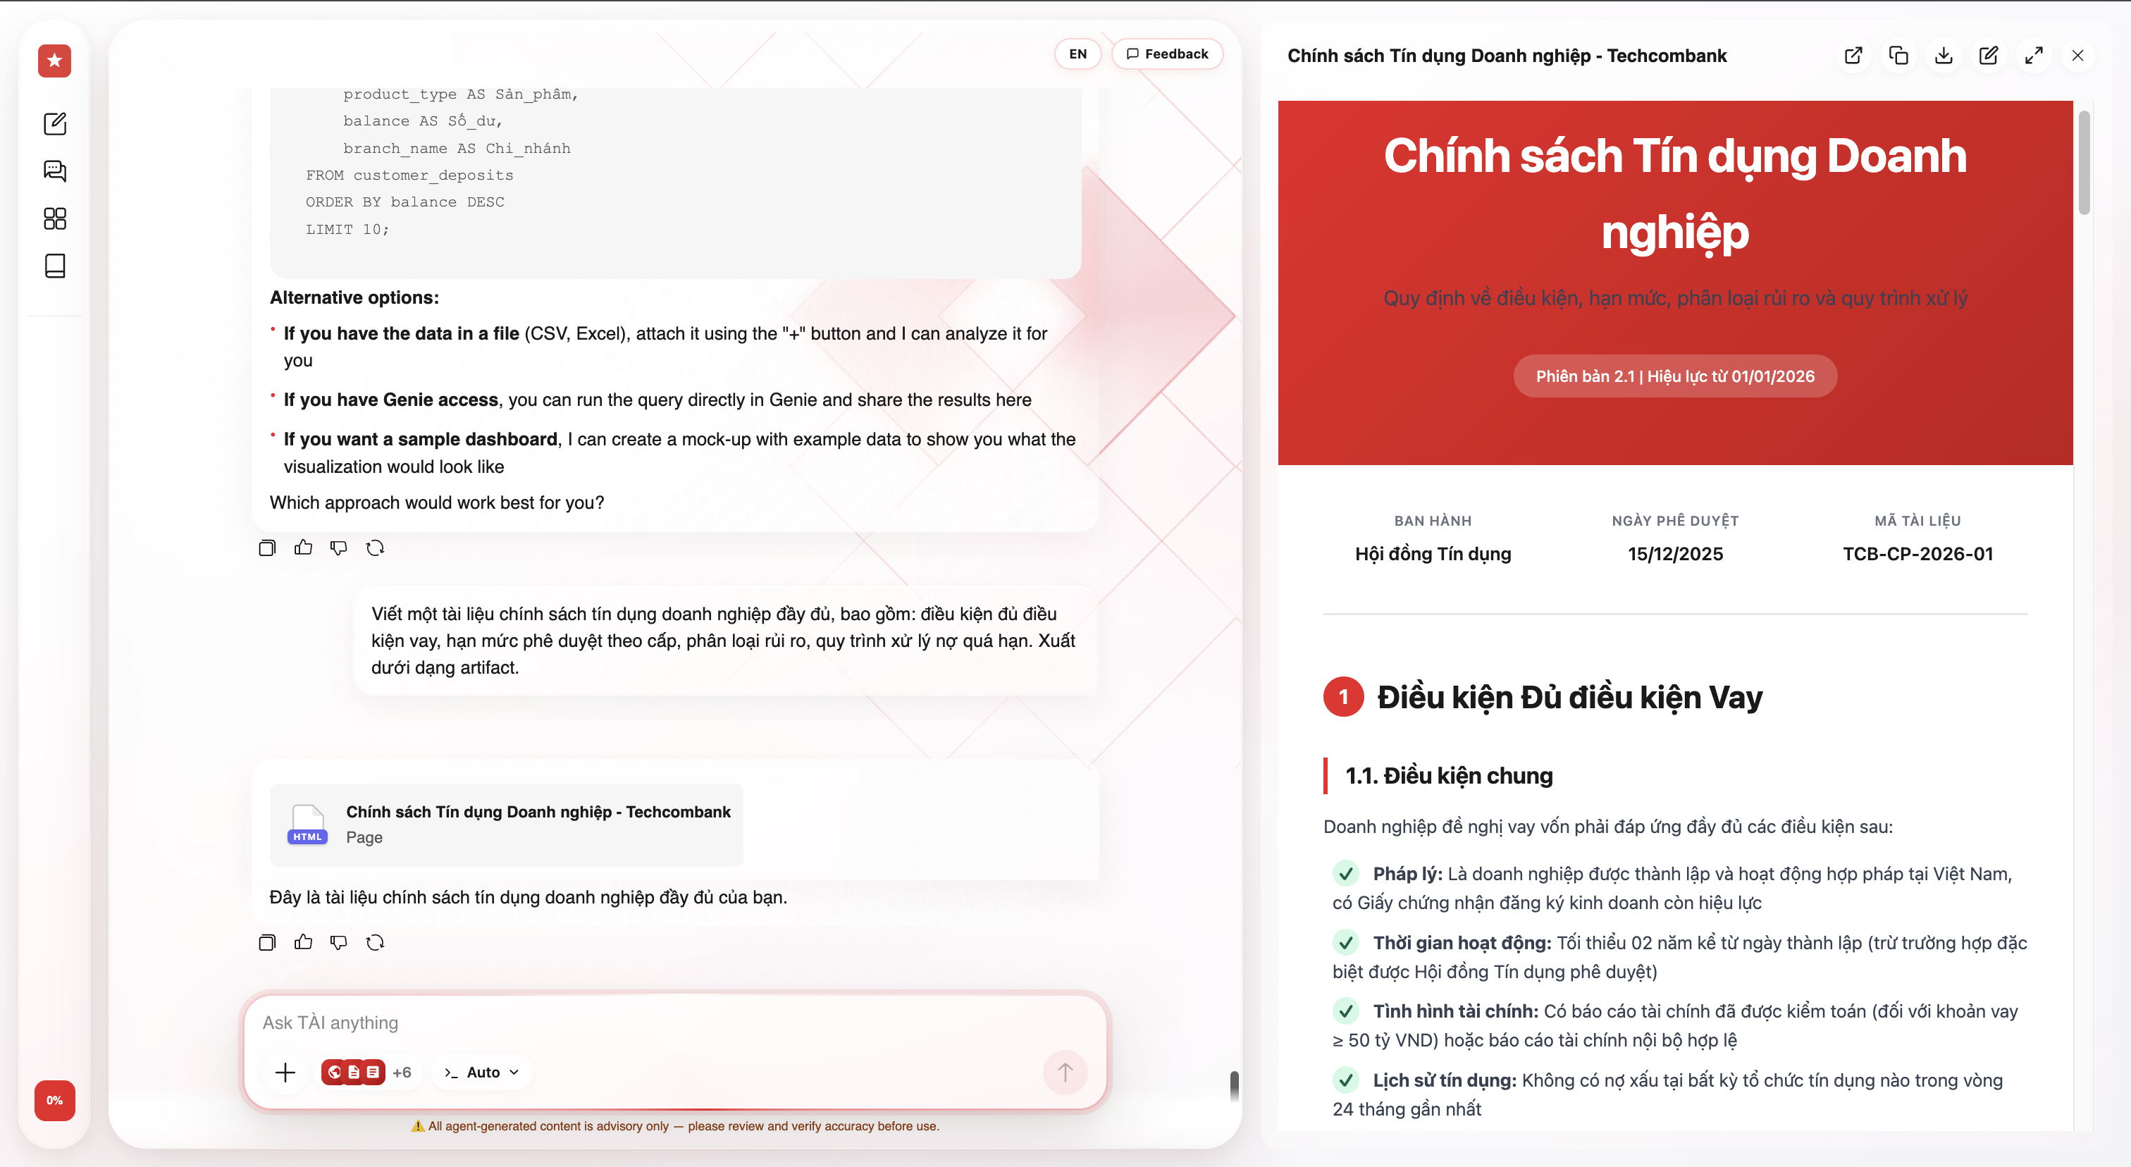
A document rendered in a dedicated panel beside the conversation. Used only when the user explicitly asks for a document/artifact, or the content is genuinely long-form.

Supported formats
Format | Renders | When to use
markdown | Long multi-section document | Reports, essays
html | Self-contained designed page (inline CSS & SVG, no network) | Polished one-pagers, under ~3000 words
code | Standalone source file | Code in a dedicated space
mermaid | Single Mermaid diagram (source only) | One diagram, no prose
svg | Complete inline illustration | Self-contained <svg>

Artifact panel features
- Copy / Download the content
- Edit inline — select text and give an instruction
- Version navigation — history, diff between versions, restore older versions
- Preview / Code toggle for renderable types

Brand constraints (HTML artifacts)
Rule | Value
Accent colour | #ed1b24 (TCB red)
Text colour | #1a1a1a
Muted colour | #6b7280
Border colour | #e5e7eb
Fonts | System fonts only — no external resources (sandboxed)
Content width | Centered at ~820–880 px
Border radius | 10–14 px
Font weight | Capped at 700
──────────────────────────────────────────────────

6. Tool-Driven Surfaces
Surfaces produced by specialist tools. Each tool renders its own UI in the chat; the model triggers the tool and the frontend draws the result.

Job cards & file cards
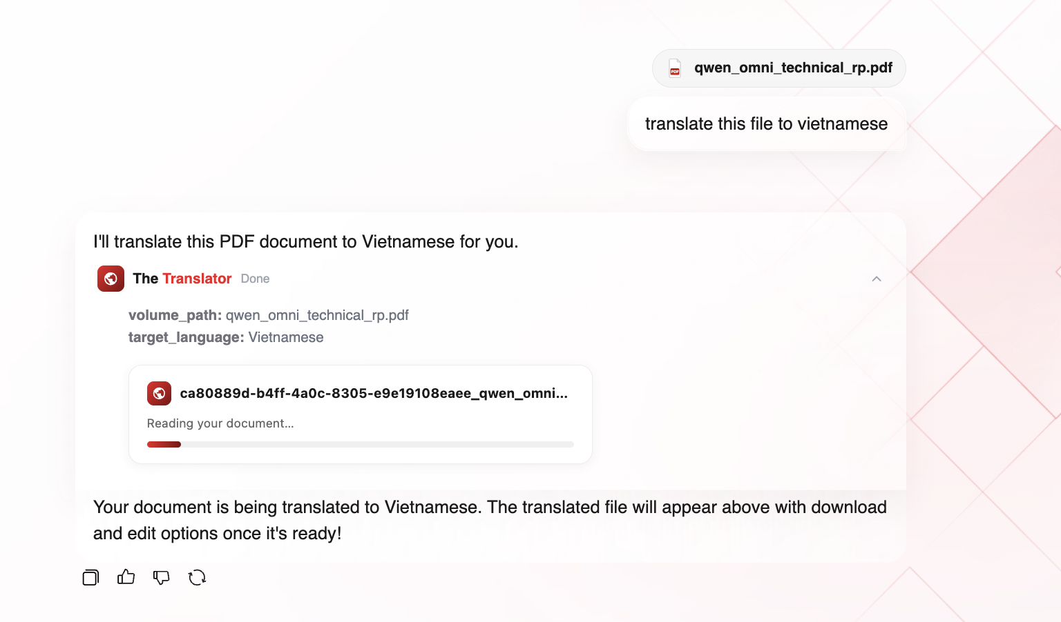
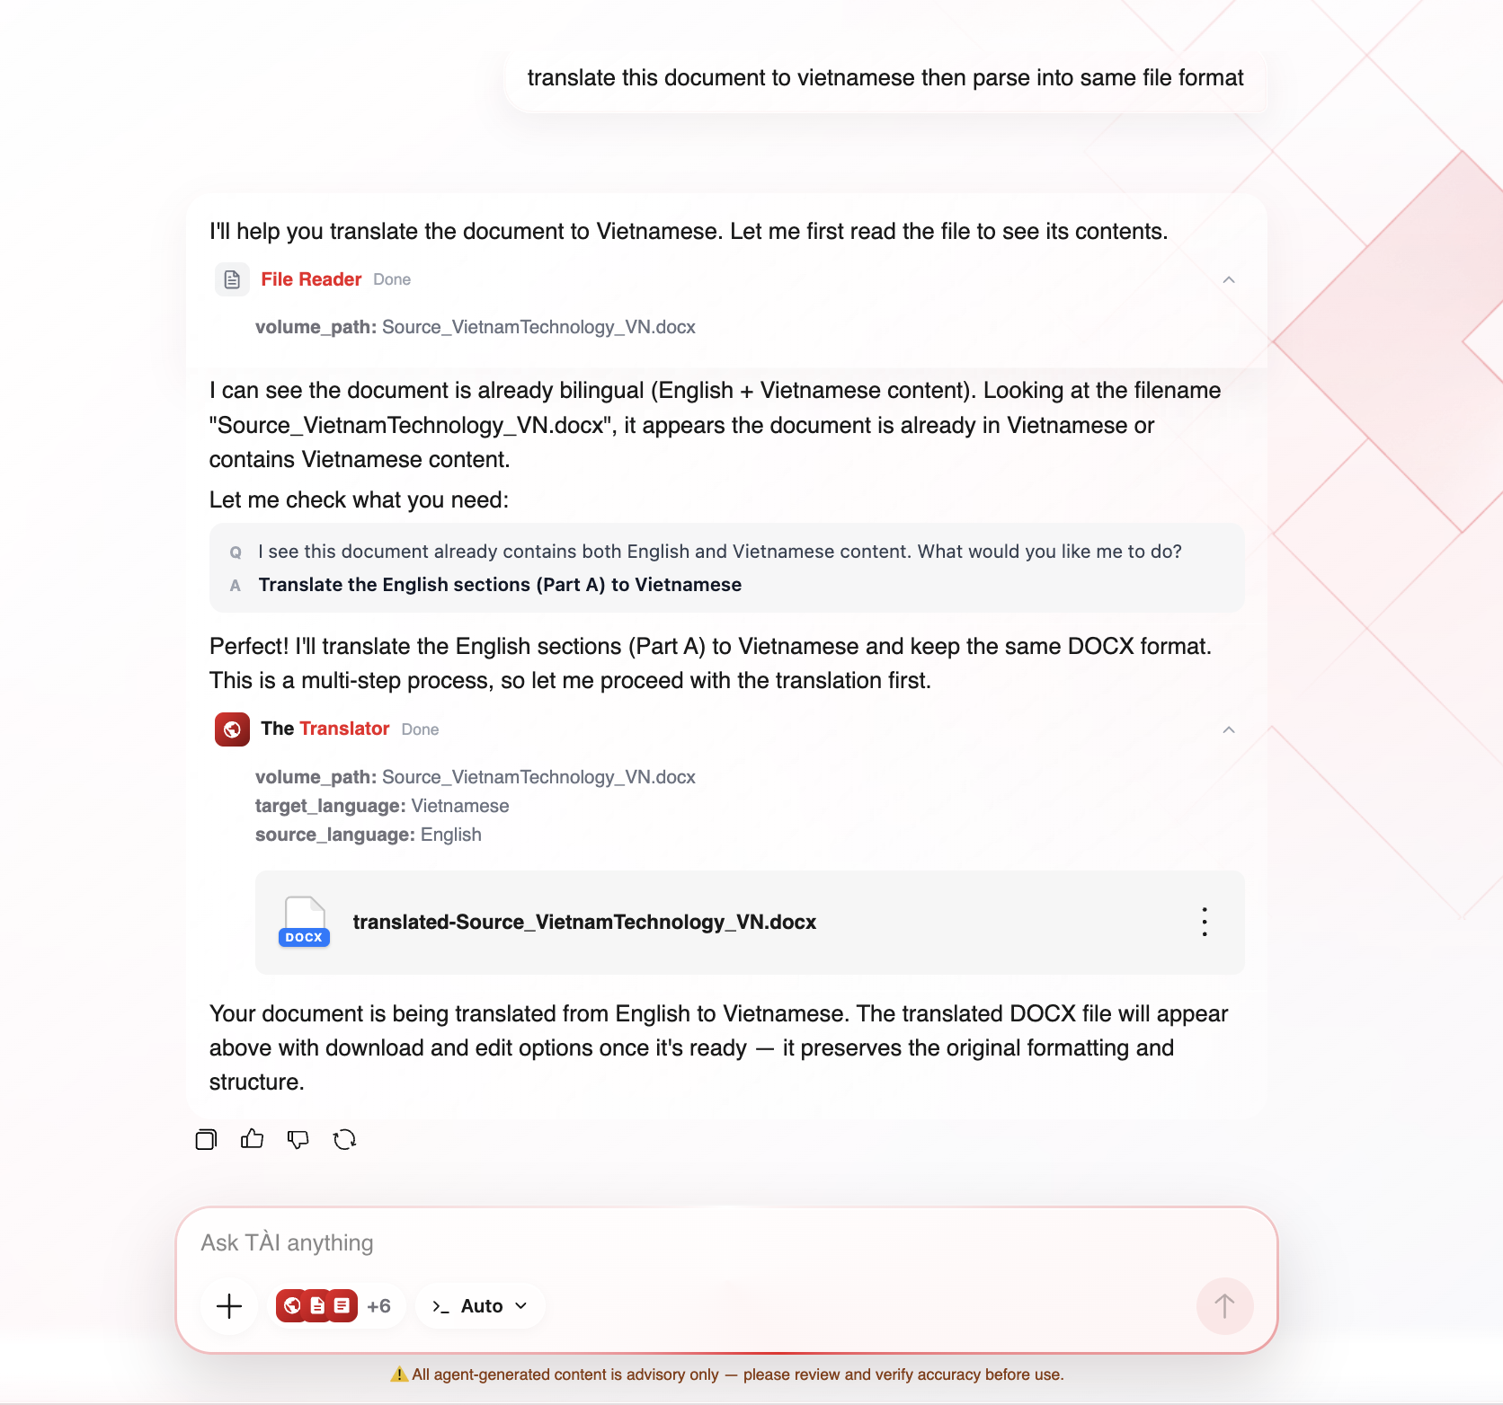
Long-running tasks (image, diagram, translation, presentation) show a job card that polls status. States: probing → queued → running → done / error / expired. You can keep chatting while it runs.

Image generation (generate_image)
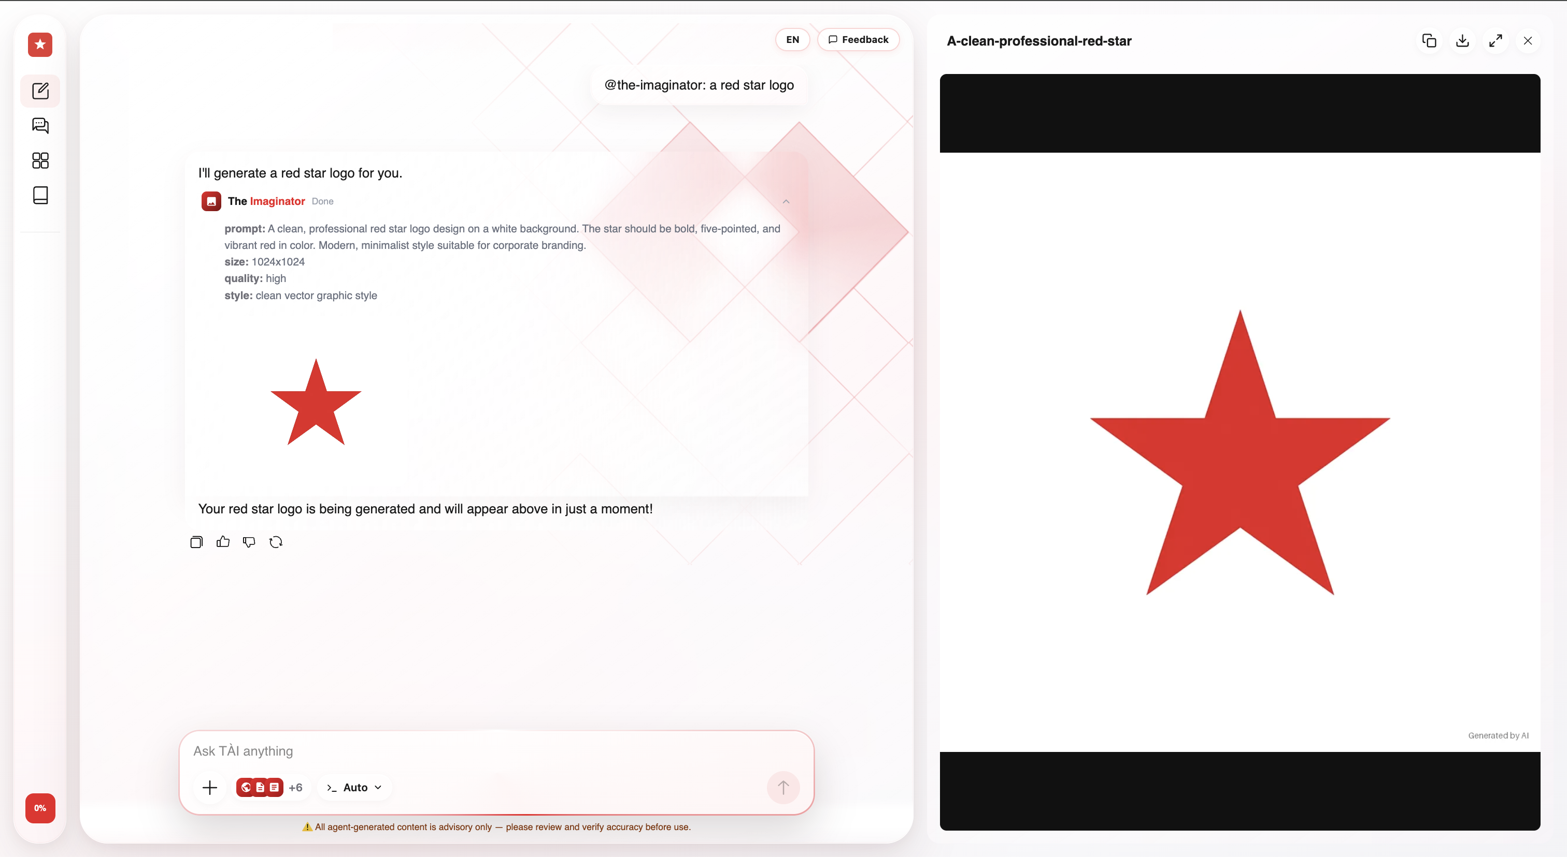
Renders images inline (square / landscape / portrait). Hover to download, click to preview full-size in the right panel.

Diagram workspace (open_diagram_workspace)
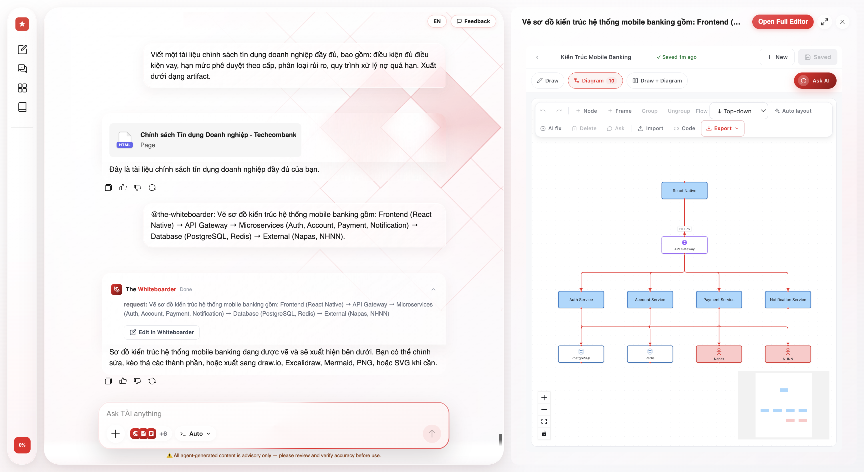
An editable diagram board. Drag/rearrange nodes, iterate across turns, export to draw.io / Excalidraw / XMind.

Document tools (hand-off cards)
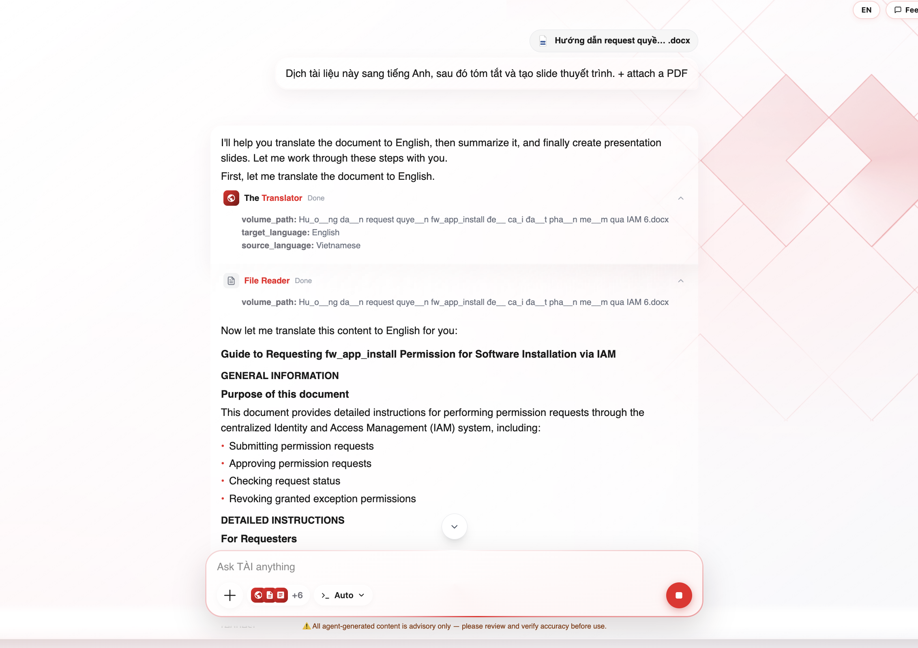
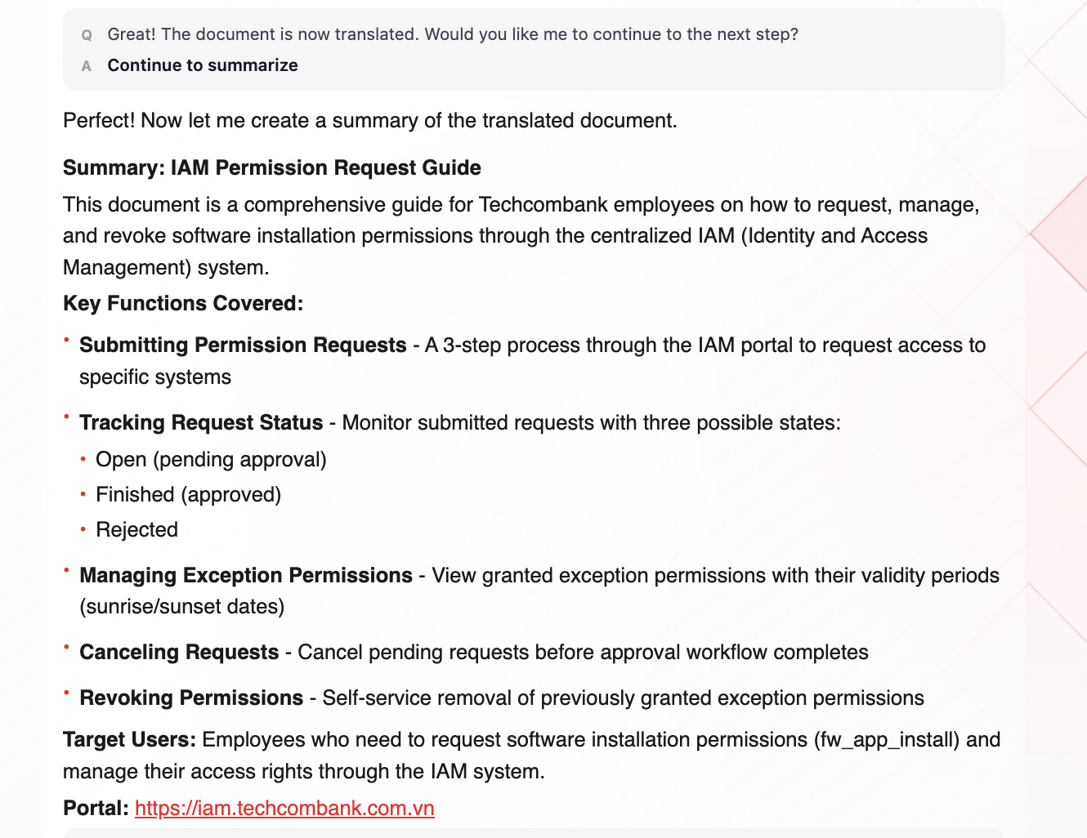
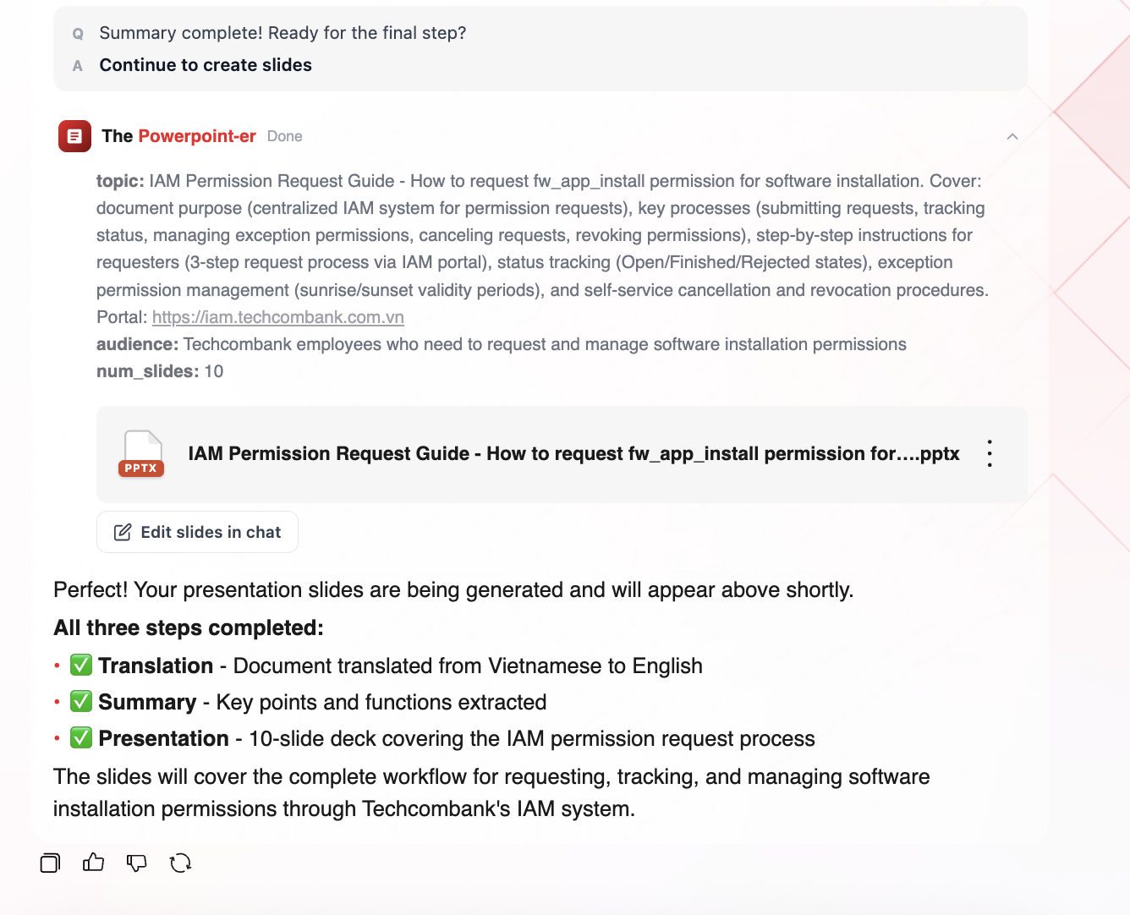
Tool | What appears
translate_document | File card with download + preview
summarize_documents | Summary + "Open mind map in Summarizer"
generate_presentation | PPTX card + "Edit slides in chat"

Clarification card (ask_clarification)
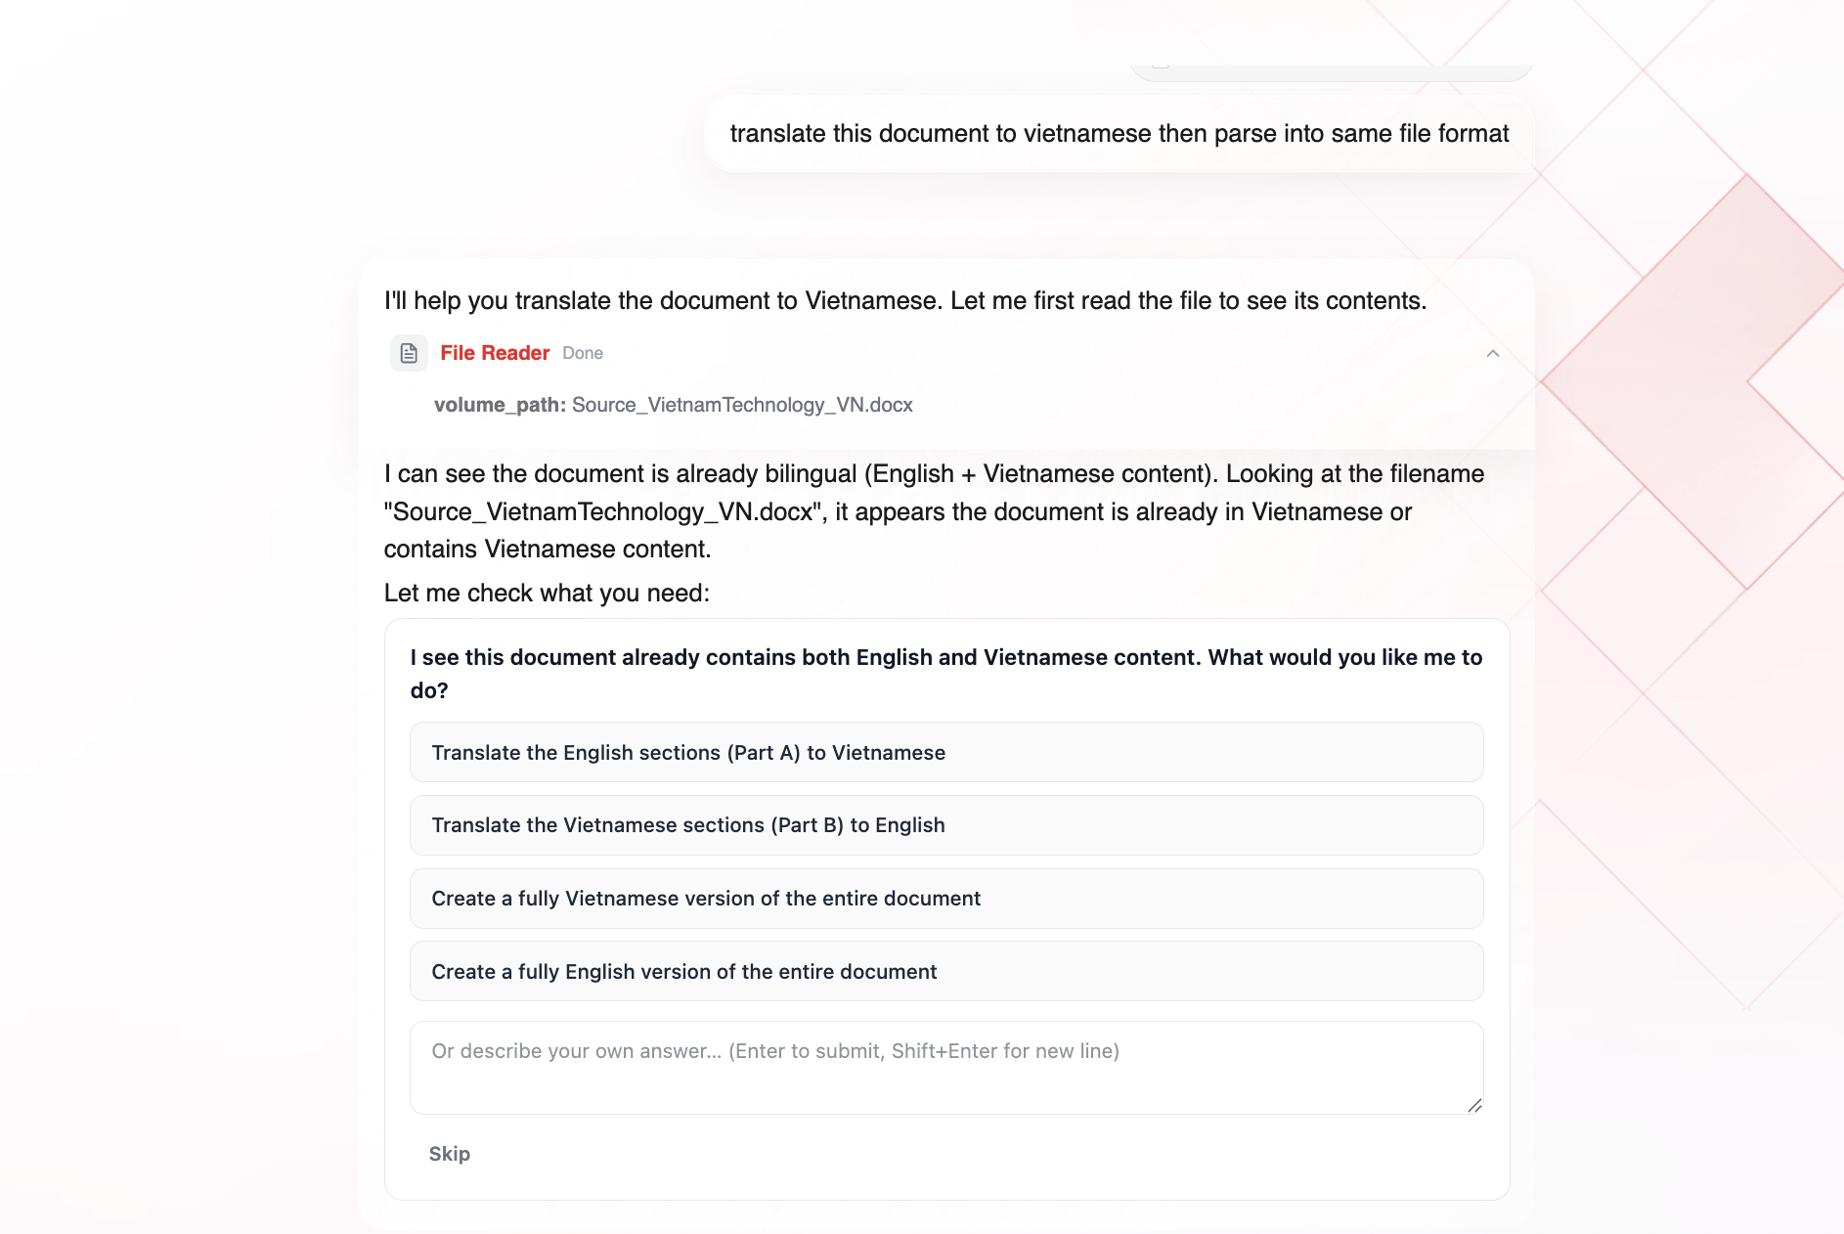
One question with 2–4 option buttons plus a free-text field. Pauses the turn for your choice. Maximum 2–3 clarification rounds.
──────────────────────────────────────────────────

7. Decision Rules — Which Surface, and When
The decision order the model follows:
Rule 1: Inline markdown (default). Text, small tables, code, mermaid, LaTeX. When in doubt, answer inline.
Rule 2: Generative UI (render_a2ui) when quantitative data is clearer as a visual, or the user asks for a dashboard/chart.
- ❗ Rows from a query tool (Genie/SQL) → always DataTable, NEVER markdown table
- ❗ At most ~30 rows per table; state the true total in the caption
- ❗ Every surface followed by exactly one caption sentence
Rule 3: Clarify (ask_clarification) when the request is ambiguous, or chaining 2+ document operations (translate → summarize → slides) — pause after each step for the user to review. Max 2–3 rounds.
Rule 4: Side-panel artifact (openArtifact) only when the user explicitly asks for a document, or the content is genuinely long-form / a designed page.
──────────────────────────────────────────────────

8. Response Actions
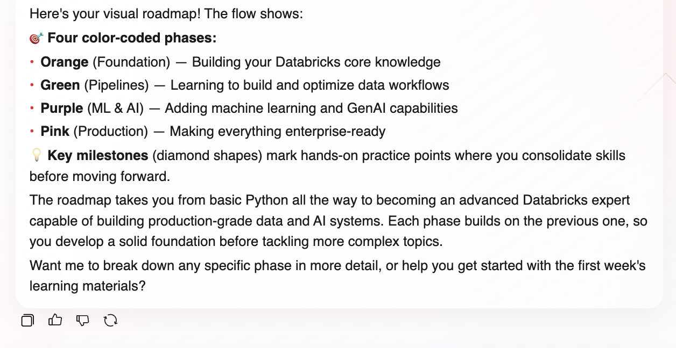
Action | What it does
Copy | Copy the response to clipboard
👍 / 👎 | Rate the response (opens a feedback form)
Regenerate | Get a different response for the same question
You can edit any sent message (hover → Edit) to re-run with changes. A version navigator < 1/2 > lets you switch between branches.
──────────────────────────────────────────────────

9. Token Meter
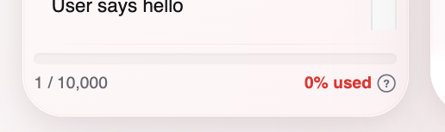
The sidebar shows your token usage (e.g., 3 / 10,000). Tips to save tokens:
- Start a new chat for a new topic
- Attach only the files you need
- Ask one focused question at a time
At 90% usage, the bar turns red with a warning.
──────────────────────────────────────────────────

Tips
- Be specific: "Create a 5-slide presentation about cloud security" → gets slides. "Tell me about cloud security" → gets text.
- Use @ to go directly to a specialist.
- Use inline editing in the artifact panel instead of asking TÀI to rewrite everything.
- Job cards update automatically — keep chatting while they run.
- If you need a polished report, ask for an "HTML artifact" — it opens as a designed page in the side panel.
──────────────────────────────────────────────────

Limitations
Limitation | Detail
No DOCX/XLSX preview | Download only — no inline preview for these types
No per-card cancel | Use the global Stop button to halt all processing
Language follows your prompt | The EN/VI toggle changes UI only, not response language
Context Hub | Shows "COMING SOON" — not available yet
~30 row cap on DataTable | Larger datasets are truncated; true total is in the caption
──────────────────────────────────────────────────
⚠️ All agent-generated content is advisory only — please review and verify accuracy before use.
──────────────────────────────────────────────────
Last updated: 13/08/2026

